PRE-BREEDING CHECKLIST

With CowManager, having full control over your cattle is a breeze.
Following the steps in this check list is essential for a smooth breeding season.

FOLLOW THESE STEPS

- CHECK AND REPLACE YOUR SPI AND LOST SENSORS
- IS YOUR COWMANAGER COW DATA UP TO DATE?
- ARE ALL YOUR COWS LINKED TO A SENSOR?
- DO YOU HAVE OUT OF HERD COWS LINKED TO A SENSOR?
- MAKE SURE ALL COORDINATORS & ROUTERS ARE ONLINE
- CHECK IF YOUR ONLINE NETWORK PLAN IS UP TO DATE
- MAKE SURE YOUR WINDOWS IS UP TO DATE
- CHECK (POSSIBLE) AUTO DRAFTING FUNCTIONALITIES
- WHAT’S THE FERILITY INSIGHTS STATUS OF YOUR COWS?
- CHECK IF YOUR COMPANY SETTINGS ARE CORRECT
- ALLOW SYSTEM NOTIFICATIONS DURING MATING

If you need help with anything, please don’t hesitate to contact your local CowManager representative, or contact support@cowmanager.com.

CHECK AND REPLACE YOUR SPI AND LOST SENSORS

Don’t forget to replace all SPI sensors to keep your system up to date. These sensors can be replaced with the 5% spare sensors you already have on-farm. If more replacement sensors are needed, contact your CowManager representative.

Marking lost sensors as such will also help ensure an adequate number of replacement sensors are on-hand. SPI sensors can be found in the web-application and are marked with a red triangle.

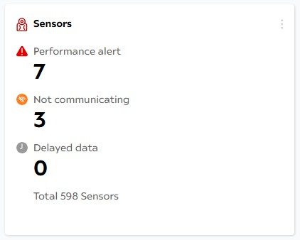

IS YOUR COWMANAGER COW DATA UP TO DATE?

In the web-application, go to ‘System Status’ ‘System’. ‘Last Update Cow Data Interface’ and ‘Last Run Cow Data Interface’ should match the current date.

- ‘Last Update Cow Data Interface’ displays the last date on which data in the system was updated
- ‘Last Run Cow Data Interface’ displays the last date on which CowManager communicated with the management program to process data

The Cow Data Interface should be run every day, once a day, at least.

Important: The Minda Drag ‘n Drop interface isn’t supported anymore. Please switch to the LIC API. Need help or more info? Contact support@cowmanager.com for assistance.

ARE ALL YOUR COWS LINKED TO A SENSOR?

To make sure you have provided all necessary cows with a sensor, check which cows on-farm are not linked. Go to ‘Cow List’ And click on the tab ‘Not Linked’ to check the cows that are not linked to a sensor.

DO YOU HAVE OUT OF HERD COWS LINKED TO A SENSOR?

Out of herd cows that are still linked to sensors can be found under ‘System Status’ ‘Sensors’ Filter ‘Cow Status’ on ‘Out of herd’. These cows will not receive any alerts. See the image below.

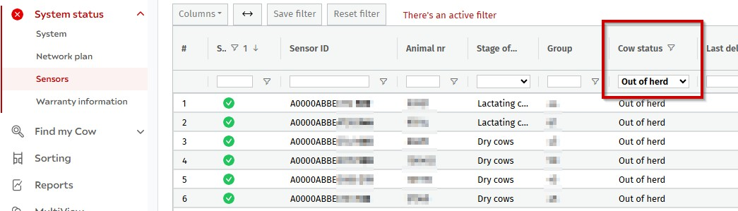

If the cows are indeed out of herd, delink them from the sensors. If these cows are still on-farm, please contact support@cowmanager.com to help you sort it.

MAKE SURE ALL COORDINATORS & ROUTERS ARE ONLINE

All individual devices can be checked under ‘System Status’ ‘System’.

- Green Checkmark = All devices are online
- Red Cross = One of the devices is offline (could be either sensors or routers)

The last column ‘Last Transmit Date’ shows at what time the devices last transmitted their data. If one of your devices is offline or their transmit date does not match the current date, please contact support@cowmanager.com to help you.

CHECK IF YOUR ONLINE NETWORK PLAN IS UP TO DATE

Find your farm under ‘System Status’ ‘Network Plan’. On the map you will see where devices have been installed on your property. The lines between the devices reflect the quality of the connection.
If any devices have been relocated, please move them to the right place in the network plan.

Tip: Name the devices to track adjustments easier.

MAKE SURE YOUR WINDOWS IS UP TO DATE

To keep you Windows system up to date, select ‘Start Settings Update & Security Windows Update’, and then select ‘Check for updates’.

CHECK (POSSIBLE) AUTO DRAFTING FUNCTIONALITIES

Are you using drafting functionalities and are they already set-up in the system? Then please check if the ‘Times’, ‘Schedules’ and ‘Areas’ are filled in correctly and that they are up to date.

Draft my Cow: Not using any of our drafting features yet? Please contact support@cowmanager.com to discuss all possibilities.

WHAT’S THE FERTILITY INSIGHTS STATUS OF YOUR COWS?

Under ‘Reports’ you can find the Fertility Insights Report. Here you can check if the cows returned in cycle or if cows have absence of heat, or irregular heats.

In case of a false heat alert, it’s possible to remove this as ‘not valid' (when using the snooze function), to keep your cow’s Fertility Insights status up to date.

Watch this video to find out how to remove or snooze alerts.

CHECK IF YOUR COMPANY SETTINGS ARE CORRECT

Under ‘Settings’ → ‘Company settings’ → ‘Heat alerts’ check if the following is set:

• ‘Suspend heat alert after insemination or heat event for lactating cows (days)’
should be set to 1 to remove the heats from the heat alert list after insemination
• ‘Show heat alert for dry cows’ should be on, when using CowManager to mate dry cows, e.g. carry overs.
• If there are cows that won't be mated that have been given a ‘do not breed’ status, make sure the ‘Hide heat alerts if cow is do not breed (DNB)’ setting
is turned on to remove their heat alerts from the list.

ALLOW SYSTEM NOTIFICATIONS DURING MATING

Make sure to turn on your push notifications before the season starts, so you’ll receive all potential system notifications during mating.

This way, you’ll be alerted immediately if anything is the matter with your system.

If you need help with anything, please don’t hesitate to contact your local CowManager representative, or contact support@cowmanager.com.

